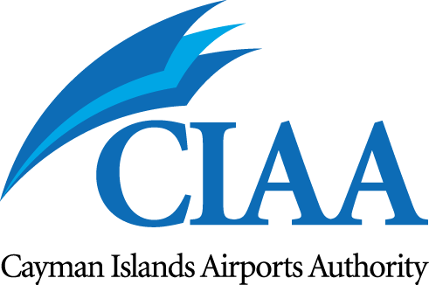

The Cayman Islands Airports Authority (CIAA) invites applications for the post of

Electronics Engineering Officer

The successful applicant will provide technical oversight and coordination activities in relation to the installation and maintenance of all new and replacement systems and equipment within the responsibility of the Communication, Navigation Surveillance (CNS) Section. The Electronics Engineering Officer Will support the CNS Maintenance Program Coordinator and a team of Aviation Electronic Technicians and also the CNS Manager and CNS team to ensure uninterrupted safe service and identifying risks to Aeronautical Telecommunications Services safety, efficiency and continuity of service.

The CIAA offers a dynamic culture and working environment, augmented by a suite of Benefits including: competitive Compensation, private sector Health Insurance, Pension Plan (6.4%), minimum of 18 days’ paid vacation per year and a generous competency & performance–based Learning and Development Plan for all eligible employees in established roles

QUALIFICATIONS & EXPERIENCE:
- A Bachelor’s degree, HND or minimum of an HNC in Electronic Technology, Telecommunications or related discipline preferred, or;
- A minimum of ten (10) years’ experience in aviation electronic engineering and maintenance of communication, navigational and surveillance systems;

PREFERRED SKILLS:
- Must have knowledge of the aviation regulatory structure in general and that of the International Civil Aviation Organization (ICAO) standards and recommended practices in Annex 10, and familiarity with other ICAO annexes, such as annex11and 14.
- Awareness of United kingdom Overseas Territories regulatory environment would be preferential, with specific references to:-
  - The UK’s Air Navigation (Overseas Territories) Order (AN (OT) O.
  - ASSI’s Overseas Territories Aviation Requirements (OTARs) covering CNS.
- Applicants trained and familiar with the operation and maintenance of the following equipment are desirable: Park Air VHF aeronautical transmitters and receivers, Frequentis 3020 Voice Switch, Selex VOR / DME, AMHS/AFTN, MET systems, Aeronautical surveillance data processing and display systems.
- Strong analytical, problem solving and fault-finding skills and be able to identify cost effective solutions.
- Proficient in the use of various electronic and aviation electronics tools and test equipment as used in an air traffic engineering environment.
- Strong Project Management Skills.
- Computer knowledge with advanced proficiency in Microsoft Office Suite including Project Management.
- Excellent oral and written communication skills as well as interpersonal skills and the ability to motivate and communicate with individuals and teams in a high pressured environment.
- Strong interpersonal, team-working, communication and supervisory skills.
- Valid driver’s license, passport and USA Visa is required.

Salary range CI$57,765.00- $86,068.00 per annum will be commensurate with experience and qualifications.

Short listed candidates will need to submit to a pre-employment drug screen, medical exam, as well as previous employment & background due diligence checks and be able to produce a clean police record, as a condition of employment. Security requirements for this position require that candidates can account for the preceding five (5) years’ of work history. Any unexplained gaps of more than 30 days will be grounds for disallowing the application.

CIAA Application forms are available at www.caymanairports.com. Completed application forms should be submitted to:

Chief Human Resources Officer, P.O. Box 10098 Grand Cayman KY1-1001 CAYMAN ISLANDS
Or emailed to: HR.Recruitment@caymanairports.

CLOSING DATE for applications – 15 January 2019

All applications will be acknowledged, but only qualified shortlisted candidates will be contacted for an interview and assessment.

